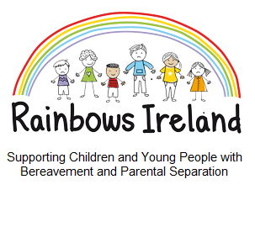

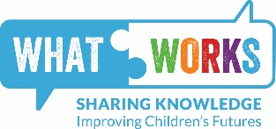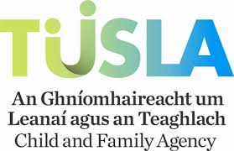

Rainbows offers a 9 week listening, group support programme for children following a bereavement or separation or divorce.

* Children of a similar age and loss experience are in separate groups.
* Rainbows is suitable for children from age 7years.
* Rainbows is not counselling or professional therapy.

Visit [www.rainbowsireland.ie](http://www.rainbowsireland.ie) for more information on the Rainbows Service.

**For local information contact:**

**Sally Mooney at Finn Valley Family Resource Centre**

**on 086 7960341/074 – 9131245.**

**Email: frcrainbows@gmail.com**

**Start date: 21st September 2023**

**Venue: Finn Valley Family Resource Centre**

**Time: 4.30pm – 6.30pm**

**Refreshments will be served**

**Contact: Sally Mooney –** [**frcrainbows@gmail.com**](mailto:frcrainbows@gmail.com) **/ 074 9131245**