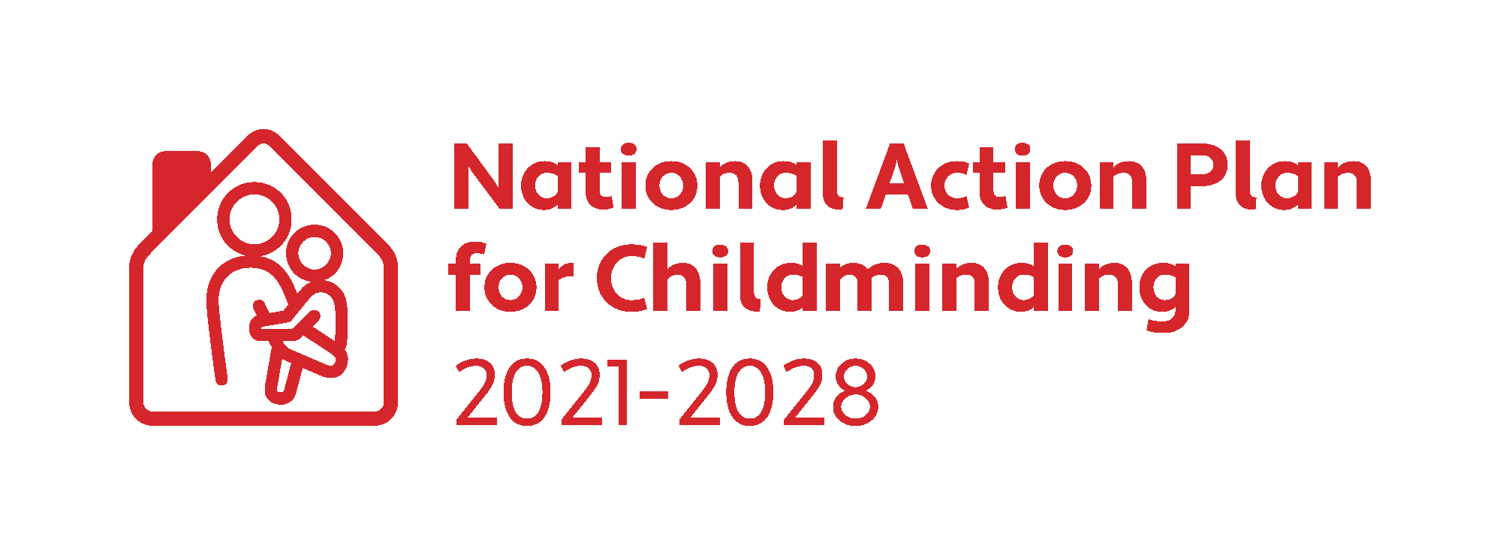

CHILDMINDING DEVELOPMENT GRANT
2023

Application Form

Closing Date for Applications: Friday 14 July 2023

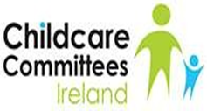
Applicant Details:

Name of Applicant:
Childminding Business Name:
(Optional)
Address of Applicant:

Mobile Telephone:
E-mail:
Name of your local City/County Childcare Committee:
I am a Tusla Registered Childminder: ☐

I am a not required to register with Tusla: ☐

I am planning to be a Childminder in 2023: ☐

I declare that I do not have any previous convictions for any offence involving violence or harm to children/adults: ☐ Yes

Evidence of Childminding Insurance submitted: ☐ Yes
Evidence of completion of Tusla Children First E-Learning Programme submitted: ☐ Yes
Current Tax Clearance Certificate submitted: ☐ Yes
By ticking this box, I agree to the retention of my contact details by the DCEDIY and my local City & County Childcare Committee for the purposes of sharing updates and engaging in consultation, relating to the implementation of the National Action Plan for Childminding 2021-2028: ☐

You can withdraw your consent at any time by emailing: CCCChildmindinglead@cavanccc.ie

Please indicate the areas on which you intend to spend the grant:

Area of spend | Tick as many as are appropriate | Approximate  spend
Outdoor Play Equipment | ☐ | €
Toys/Books | ☐ | €
Childcare & Safety Equipment | ☐ | €
Supporting Inclusion | ☐ | €
STEAM Equipment (Science/Technology/Engineering/Arts/Maths) | ☐ | €
Total Amount of CMDG applied for | € | €

Please refer to Childminding Development Grant (CMDG) Applicant Guidelines for details of eligible and ineligible spends. If you intend purchasing high-cost items, please contact your local CCC to confirm that these items are eligible under the terms of the CMDG.

(Please use block capitals)

Bank Details

Account Name:
Payee Address:
IBAN:
BIC:
Bank Name:
Bank Address:

Applicant Declaration:
I understand and agree to the following terms and conditions:

- On approval and acceptance of these terms and conditions, the grant is paid 75% in advance and 25% in arrears.
- I will return all itemised receipts for eligible expenditure to Sligo County Childcare Committee (CCC) with the CMDG Expenditure Report. (See applicant guidelines).
- Where required, I am compliant with the Child Care Act 1991(Early Years Services) Regulations 2016 and/or Child Care Act 1991 (Early Years Services) (Registration of School Age Services) Regulations 2018; Fire Services Act 1981 & 2003 and the Building Control Acts 1990 and 2007.
- The grant will only be paid when the full application submitted has been assessed and approved.
- If my application for funding is successful, and the CMDG national budget is oversubscribed, I may receive a lesser amount than I applied for.
- To submit all receipts and any evidence of compliance, with the CMDG Expenditure Report to Sligo CCC any time before 27 October 2023. Failure to submit the CMDG Expenditure report and receipts will result in Sligo CCC taking the necessary steps to recover the grant already awarded. It may also affect future applications for funding.
- I understand that the grant money is not tax free.
- I may receive a compliance visit, I will receive notice of such a visit, and I agree to provide reasonable assistance during such visit.
- To continue to provide a childminding service for at least 12 months following receipt of the grant.
- If I cease or do not start to childmind within 12 months of receipt of the grant, Sligo CCC may take the necessary steps to recoup the funding or a portion of the funding, see Repayment of Grant Aid to Sligo CCC.
- Any unspent funds from the first 75% awarded must be returned to Sligo CCC.
- All or part of this grant may need to be returned if the expenditure has been deemed ineligible by Sligo CCC.
- Any failure of technology or disruption to internet services affecting submission of the application will be at my own risk and neither the CCCs nor the DCEDIY accepts any liability if the full application fails to be submitted with supporting documentation or is rejected as a late submission.
- I hereby give authorisation to Sligo CCC to make an online payment transfer to my bank account.
- This signed completed application form will outline the terms and conditions that represent the contract between myself and Sligo CCC/DCEDIY.
- I agree to indemnify Sligo CCC, Pobal and the Exchequer from and against all actions, proceedings and costs, claims, demands and liabilities howsoever, arising from all and every action in connection with the approved project.
- I declare that the information provided is true and complete.

Repayment of Grant Aid to Sligo County Childcare Committee
Sligo CCC can cancel the grant, withhold any grant monies unpaid to date, and look for repayment of any monies that have already been paid to the successful applicant, if the successful applicant fails to comply with the terms of this agreement.

Disclosure under the Freedom of Information
Under the Freedom of Information Act 2014, the information in this document and its attachments may be released on request to third parties.
If you believe that any of the information in this document is sensitive and should not be disclosed to a third party, you must identify the sensitive information and provide the reason(s) for its sensitivity at the time of the application.
You will be consulted about the sensitive information before any decision is made to release the information to a third party. If you do not identify any of the information supplied in this document and supporting documentation as being sensitive you are acknowledging that any, or all of the information supplied, may be released in response to a Freedom of Information request.
Please outline the sensitive information and the reason(s) for the sensitivity below and submit with your application:

General Data Protection Regulations:
All records and data will be processed in compliance with GDPR. Please see the DCEDIY Privacy Notice for further information.

Early Learning and Care Services and School Age Childcare Services must ensure that they are fully aware and comply with their obligations and responsibilities in relation to processing personal data within their service(s). Please refer to the Data Protection Commission for additional information in relation obligations in relation to GDPR. Here is a link to their website: Data Protection Commission Guidance

Sligo CCC/City & County Childcare Committees/Pobal/DCEDIY is the Data Controller for personal data processed for the CMDG. The DCEDIY privacy notice can be accessed at:
https://www.gov.ie/en/help/privacy-policy/

Sligo CCC/City & County Childcare Committees/Pobal/DCEDIY, as a Data Processors, will process applications under the instructions of the DCEDIY. Your information will be processed in the following ways:
• Contact details and bank account information from the application form will be used for the payment process for this grant.
• The information contained in your application form may be used for research purposes by the DCEDIY or Pobal in relation to the impact of this funding on the early years’ sector.
• As part of the administration and management of this grant DCEDIY or Pobal may share the information in this application form with other Departments, Statutory Bodies or their agents.

By signing below, I confirm I have read, understand, and accept the terms and conditions outlined above in this Application & Declaration.

Applicants Signature: ___________________________ Date: _______________________

Completed Applications to be sent to rosaleen@donegalccc.com by 5pm Friday 14 July 2023
Name of Contact Person
Address of City/County Childcare Committee.

Eircode:

Phone Number

Email address.

PLEASE NOTE:
Late applications will not be accepted. Only complete application forms with the relevant supporting documentation will be processed. All application forms must be scanned or posted; photographs of application forms will not be accepted.

Please tick when completed | Applicant  Please tick | CCC  Please tick
CMDG application form. Should be signed by applicant and Donegal CCC
Evidence of appropriate childminding schedule of insurance (Insurance must be in date at time of application). Note: entire Insurance Policy document is not required
Copy of Tusla Children First E-Learning Programme Certificate (dated in the last 3 years)
Current Tax Clearance Certificate in applicants name
Tick the consent for the retention of contact details for the purposes of information sharing in relation to NAPC 2021-28
Please Note: This is optional
Bank details are complete and legible
Signed applicant declaration
Donegal CCC completes, signs and/or stamps the relevant section of the form (below)
CHECKLIST FOR APPLICANT & CCC

Internal CCC Use only:

This section is completed by Donegal County Childcare Committee (CCC):

Name of CCC: ______________________________________________

CCC Staff member name: _________________________________

CCC Staff member contact details: _________________________

CCC Signature/stamp: ____________________________________

