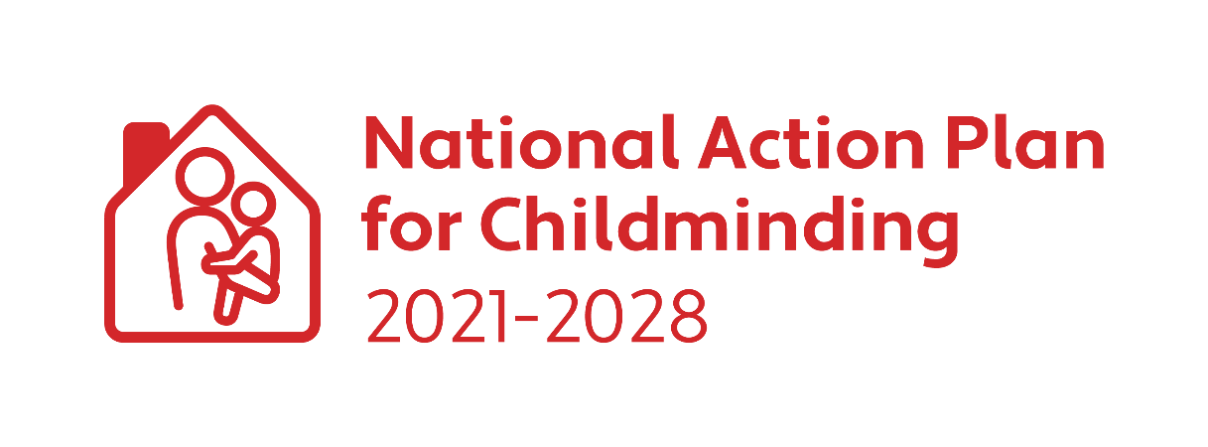

CHILDMINDING DEVELOPMENT GRANT 2023

Applicant Guidelines

Closing Date for Applications: Friday 14 July 2023

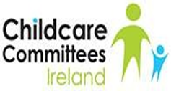
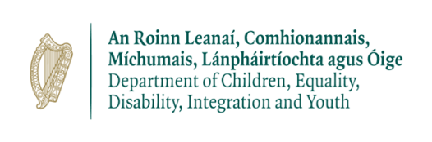
What is a Childminding Development Grant (CMDG)?
The CMDG is a small grant designed to assist existing and potential childminders to enhance the safety and quality of their childminding service.

What funding is available under the grant?
A grant of up to €1,000 is available to an eligible childminder. All childminders can apply for the full Childminding Development Grant every year. However, if the CMDG national budget is oversubscribed, an applicant may receive a lesser amount than applied for (see section on Oversubscription Procedure). Successful applicants are paid 75% of the grant in advance. Following submission and approval of the CMDG Expenditure Report and receipts for the full amount granted, the remaining 25% is paid to the childminder.

Who is eligible to apply for the funding?
All existing or potential childminders. Where a Childminder is subject to the Child Care Act 1991 (Early Years Services) Regulations 2016 and (Early Years Services) (Registrations of School Age) Regulations 2018, they must register their service with Tusla.

What supporting information/documentation must be submitted with the application form?
- Fully completed application form co-signed by applicant and Donegal County Childcare Committee.
- Evidence of appropriate childminding insurance. (Submit a copy of the schedule of insurance, which must be in date).
- Copy of Tusla Children First E-Learning Programme certificate (Must be dated within last 3 years).
- Current Tax Clearance Certificate in applicant’s name (See FAQ section on how to access Tax Clearance Certificate).

What can the grant be used for?
The CMDG can be used to purchase items that enhance safety and quality in the childminding service. The final decision on eligible expenditure will be at the discretion of Sligo County Childcare Committee. The following list (which is not exhaustive) gives examples of the different types of costs that are eligible and ineligible for the grant. Please note that minor adaptations are ineligible expenditure for this grant. Ineligible expenditure also applies to a part payment for an item. Any item purchased must not cost more than the total awarded.

Eligible Expenditure (This is not an exhaustive list)
Outdoor Play Equipment: Sand box; water tray; swing sets, climbing frames, slides, outdoor play equipment, etc.

Toys & Books: Developmentally and culturally appropriate toys and books e.g., ride on toys; building blocks; books; dress-up; teddys/dolls/figurines; music; imaginative play items; jigsaws, board games; arts & crafts materials and supplies, etc.

Childcare & Safety Equipment: Pram; buggy; car seat; cot; high chair; child size table & chairs; stairgate; fire blanket; fire extinguisher; smoke alarm; socket covers; cupboard locks; first aid kit; blind cord safety clips, etc.

Supporting Inclusion: Sensory toys & equipment e.g., black out tent; theraputty; chewlery; weighted blanket; trikes & ride on toys; fidget toys; move and sit cushions, sensory garden, etc.

STEAM (Science/Technology/Engineering/Arts/Mathematics):
Science : Light box, microscope, télescope, etc.
Technology: Coding Kits; robot kit; robotic arms; snap electric circuits; cameras; hydraulics, etc.
Engineering: Toolbox; stem construction kit; Lego; Lego technic; magnets, etc.
Arts: Music & Literature; musical instruments; easels; painting tools and accessories; playdough & accessories; arts and crafts supplies; speakers; lights, etc.
Mathematics: Magnet tiles; IQ puzzle games; mathematic games; rubik’s cubes/tower; measuring equipment, etc.

Ineligible expenditure (This is not an exhaustive list)

- Minor adaptations or capital works such as outdoor surfacing, outdoor fencing, minor works to the house or outdoor area, painting, decorating, flooring etc.
- Trampolines; Bouncy Castles; Swimming Pool
- Subscriptions; memberships and registrations
- Baby walkers
- Travel cots and/or travel cot mattress
- Games consoles
- Second hand items
- Any items that would be considered for home use only and not childminding use e.g.
IT equipment; T.V etc.
- Insurance and/or other business expenses
- Training and Continuous Professional Development Courses
- Any item that costs more than the total grant awarded i.e., part-payment for an item.

How to apply:
- Contact Donegal County Childcare Committee (DCCC) for information and support.
- If you don’t have access to scanning/printing facilities, please contact DCCC for support. Please note photos and/or screenshots of application forms and/or accompanying documentation cannot be processed.
- Your application should be completed and signed by you and DCCC.
- Your application must include the following: a copy of an appropriate insurance schedule, a copy of your Tusla Children First e-learning Programme certificate (dated in the last 3 years) and a Tax Clearance Certificate in your name (see FAQs).
- You should post or email a copy of your application form and documents to: rosaleen@donegalccc.com, Rosaleen Breslin, Donegal County Childcare Committee, Unit 4 B, Riverside Retail & Office Park, Letterkenny, Co. Donegal F92 XH2X.
- You will receive an email from DCCC confirming receipt of application.
- DCCC will submit your application to Sligo CCC who are administering the grant funds.
- If your application for the CMDG is approved, you will receive an email from Sligo County Childcare Committee to let you know the total amount you are being awarded. You need to reply to that email to confirm that you are accepting the grant. This will act as your acceptance of the terms and conditions of the grant as outlined on the application form.
- On receipt of the acceptance email, Sligo CCC will make a payment of 75% of the total grant award into the bank account indicated on the application form.
- You must spend the full grant amount awarded to you, then you can complete the CMDG Expenditure Report and submit this, with all of the relevant receipts to Sligo CCC
- The final date for receipt of expenditure reports is the 27th October 2023. However, you do not have to wait until the closing date. You can submit your expenditure report as soon as you have spent the full grant amount or the portion you wish to spend.
- If you no longer need the full amount awarded, you can submit your expenditure report, outlining the amount spent. Sligo CCC will contact you to arrange the repayment of outstanding grant money. (See FAQs for details).
- Sligo CCC appraise the expenditure report and receipts. If they deem all the expenditure eligible under the terms and conditions of the CMDG, you will be paid the outstanding 25% of the grant and will receive an email confirming same.
- If you have been unsuccessful, you will be informed via email from Sligo CCC.
- Your application cannot be processed without all of the relevant supporting documentation.
- Late applications will not be accepted.
- No purchases should be made until grant approval notification is received from Sligo CCC. Purchases made before grant approval will be considered ineligible.
- Applications must be submitted by close of business Friday 14 July 2023.
CMDG Expenditure Report Appraisal:
- All successful applicants are requested to complete their CMDG Expenditure Report after spending the full grant that was awarded.
- All receipts must be dated following the approval of the grant and before 13th October 2023.
- All successful applicants must email/post their CMDG Expenditure Report and receipts for the full grant awarded to Sligo CCC for appraisal. Please note screenshots or pictures of receipts will not be accepted. Receipts must be scanned or photocopied. You can contact your local CCC for assistance if you do not have access to a scanner.
- If Sligo CCC deem all expenditure eligible the remaining 25% of the CMDG will be paid directly to the applicant’s bank account.
- If Sligo CCC deem any items as ineligible, they will contact the applicant directly:
- If the ineligible spend is less than 25%, Sligo CCC will deduct this amount from the remaining 25% of the grant and pay the balance.
- If the ineligible items are more than 25% of the grant, Sligo CCC will plan for this money to be repaid to Sligo CCC before the 30th of November 2023.
- Any successful applicant who does not return ineligible spend monies, will be unable to apply for future grants and funding. Sligo CCC will take the necessary steps to recoup the funding in accordance with the terms and conditions set out in the application form and childminder declaration.
- If a successful applicant ceases/does not begin childminding within 12 months of receipt of grant aid, Sligo CCC may take the necessary steps to recoup the funding in accordance with terms and conditions set out in the application form and childminder declaration.
Oversubscription Procedure:
If the CMDG funding is oversubscribed, all successful applicants will receive an equal percentage of the grant amount applied for on their CMDG application. The percentage will be determined by the percentage of oversubscribed CMDG applications. Applicants will be informed by Sligo CCC at the grant approval stage of the process if this occurs.

