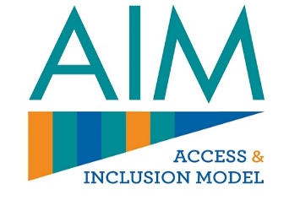
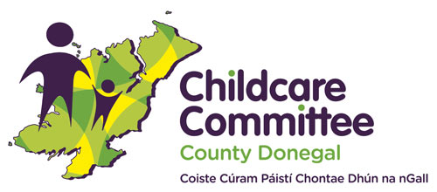
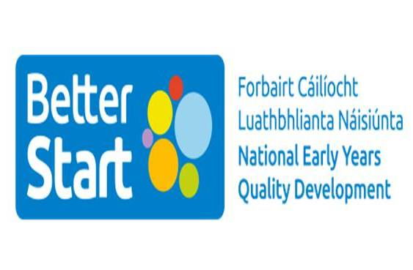

Access & Inclusion Model (AIM) Information Session
Is your child attending preschool or due to start the free preschool programme in September 2023?
Do you have any concerns about their development / interactions and feel additional support in their preschool might help?
The Access & Inclusion Model (AIM) is designed to help all children get the most out of their preschool years.
Donegal County Childcare Committee, along with the Better Start AIM Team, will host an online information session for parents interested in finding out more about the AIM programme.
The Information Session will take place online on Tuesday 9th May, 7pm – 8.30pm.
Please click on the link below to book your place:
AIM Information Session for Parents Tues 9th May

