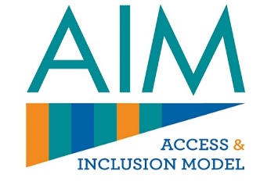
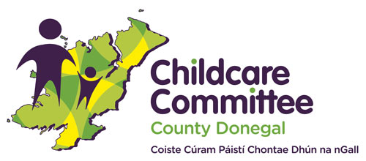
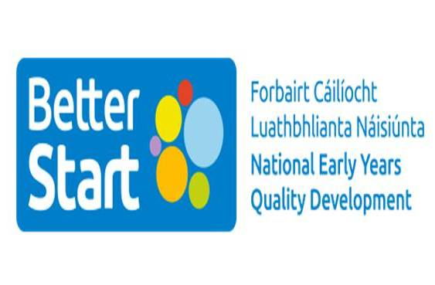

Access & Inclusion Model (AIM) Information Session
Donegal County Childcare Committee, along with the Better Start AIM Team, would like to invite Early Years Educators and Providers to an online information on AIM.
The session will include information on Level 4 mentoring, the role of the Early Years Specialist and the Level 7 application process.

The Information Session will take place on two separate dates;
Wednesday 17th May at 7pm and Wednesday 7th June at 1pm.
Please click on the Eventbrite link below to book your place on the date of your choice:
AIM Information Session 17th May 2023
AIM Information Session 7th June 2023

